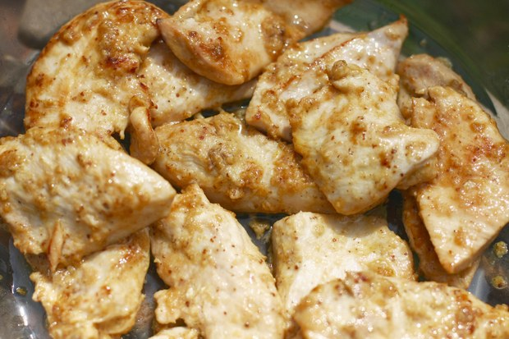
Mustard Chicken
4 Servings

Ingredients
8 oz chicken broth
½ cup chopped onions
¼ cup plus 2 tablespoons Dijon mustard
6 garlic cloves, minced
2 tsp Worcestershire sauce
1/8 tsp Tabasco
2 tbsp butter
2 tbsp olive oil
4 boneless skinless chicken breasts
1 tsp dried thyme
Chopped fresh parsley

Directions
- Combine first 6 ingredients in small bowl.
- Melt butter with oil in heavy skillet over medium-high heat.
- Season chicken with salt and pepper. Add to skillet and sprinkle with thyme.
- Cook until chicken is golden brown, turning occasionally, about 10 minutes.
- Pour mustard mixture over chicken.
- Cover and reduce heat to low. Simmer until chicken is just cooked through, about 20 minutes.
- Using slotted spoon, transfer chicken to platter.
- Cover chicken with foil and keep warm. Boil liquid in skillet until reduced to sauce consistency, stirring occasionally, about 7 minutes.
- Pour sauce over chicken and serve.

